Kuala Lumpur, Malaysia : 3rd July 2025
GACOPA congratulates the Malaysian Association of Medical Assistants and looks forward to even stronger collaborations ahead.
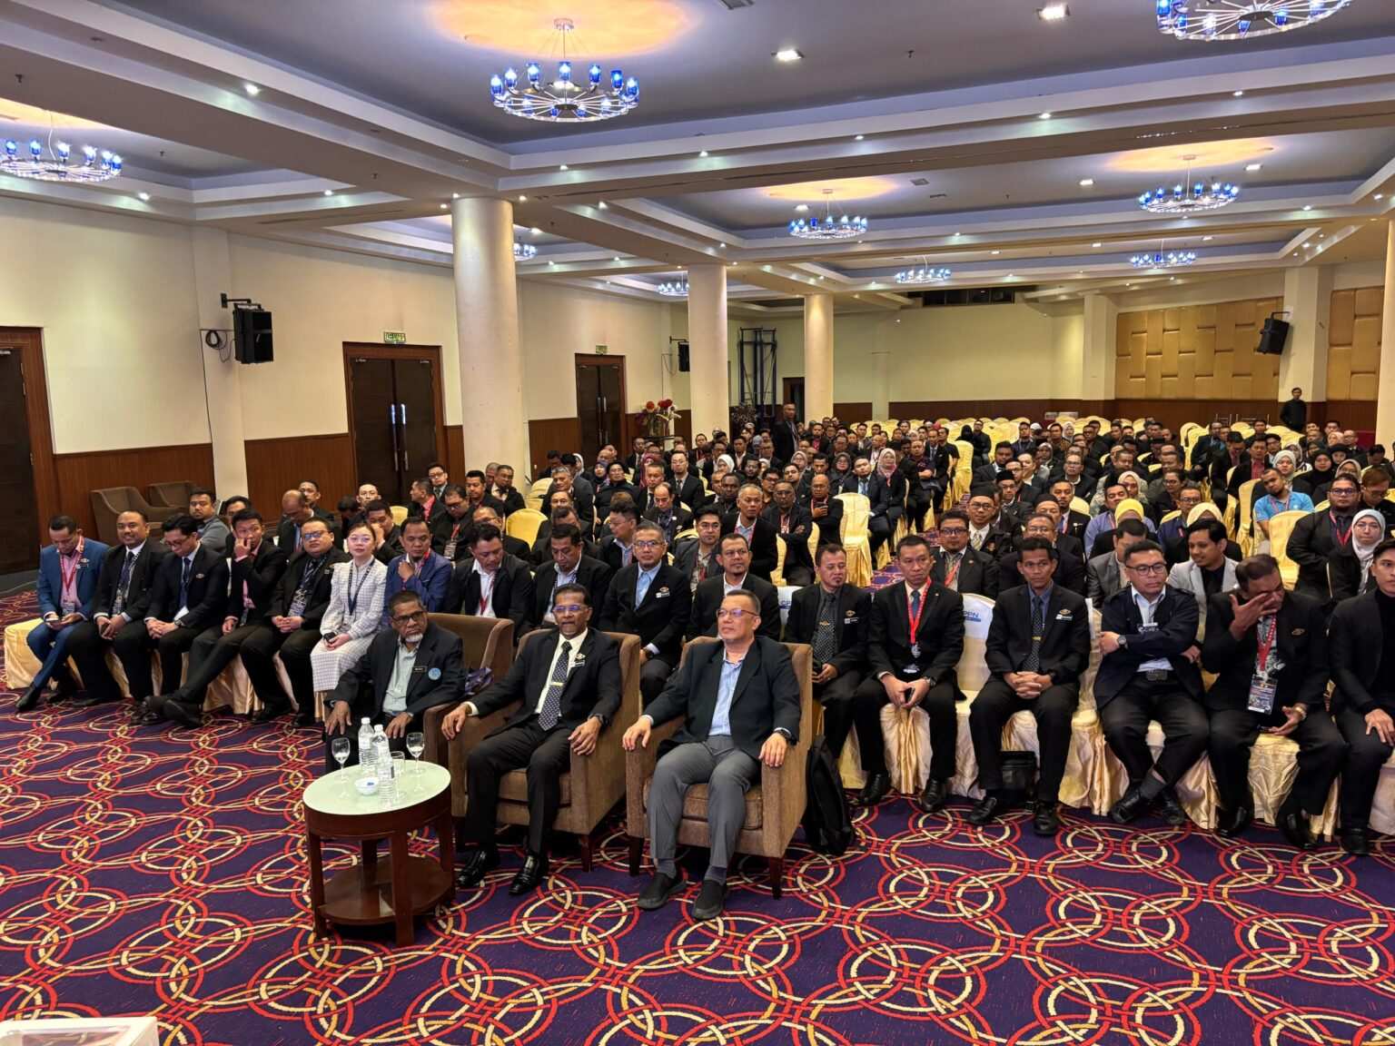
The 9th National Conference of Medical Assistants (NCMA 2025) was successfully held from 3rd to 6th July 2025 at the Oriental Crystal Hotel in Kajang, Selangor, Malaysia. Organized by the Malaysian Association of Medical Assistants (MAMA), the landmark event brought together over 300 participants from across the country, including healthcare professionals, educators, policymakers, and medical assistants.
Held under the transformative theme, “Digital Revolution: The Evolution of the Smart Medical Assistant,” NCMA 2025 offered a forward-looking platform to explore how digital innovation is redefining the roles, responsibilities, and education of medical assistants in Malaysia and beyond.
The four-day event featured a series of high-impact plenary sessions, expert forums, practical workshops, and a remarkable townhall engagement with Malaysia’s Minister of Health and the Director-General of Health. These sessions sparked critical conversations on the integration of digital tools in healthcare, professional autonomy, the future of medical assistant training, and the expanding scope of the profession in a tech-driven health system.
Throughout the conference, delegates engaged with emerging topics such as:
Smart technologies and AI in clinical care
Digital professionalism and ethical frameworks
Reforms in medical assistant education and regulation
Strengthening leadership and visibility of medical assistants in national health policy
Although GACOPA could not be physically represented at this year’s event, President Austin Oduor Otieno issued a formal statement celebrating the milestone. He commended MAMA’s bold vision and acknowledged the association’s pivotal role in shaping regional and global discourse on mid-level healthcare cadres.
“This conference exemplifies the kind of leadership and innovation we need across the globe,” said Dr. Otieno. “MAMA’s efforts continue to inspire the profession and push the boundaries of what is possible in modern healthcare delivery.”
The conference officially concluded on 6th July 2025, followed by MAMA’s Biennial Delegates Meeting, marking a successful week of engagement, renewal, and professional advancement.
As GACOPA continues to promote international standards, collaboration, and innovation across Clinical Officers, Physician Associates, Medical Assistants, and Analogues, the success of NCMA 2025 stands as a shining example of what focused, future-ready leadership can achieve.
GACOPA congratulates the Malaysian Association of Medical Assistants and looks forward to even stronger collaborations ahead.

